PRACTICAL NO 2
Aim: Implement a Java program that defines a class with fields and methods, creates objects, and demonstrates accessing methods using objects.
Source Code:
class student {
int rollNo;
String name;
void setDetails(int r, String n){
rollNo = r;
name = n;
}
void display(){
System.out.println("Roll No: " + rollNo);
System.out.println("Name: " + name);
}
}
public class studentDemo {
public static void main(String[] args) {
student s1 = new student();
s1.setDetails(68,"Rishabh");
s1.display();
System.out.println();
student s2 = new student();
s2.setDetails(56,"Pranit");
s2.display();
}}
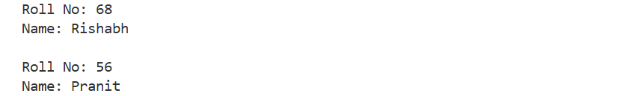
Output:

